**Experiment No.:** 07

**Experiment Name:** Implementation of Curve Fitting Methods (Polynomial least square).

**Theory:**

Curve fitting is a process used to determine a mathematical function that most accurately represents a given set of data points. It aims to describe the underlying relationship between dependent and independent variables. Depending on the pattern of data, different types of curve fitting methods are used:

* **Linear fitting:** Approximates data with a straight-line equation, y=mx+c.
* **Polynomial fitting:** Uses a polynomial equation of degree *n*, y=a0+a1x+a2x2+…+anxn, to capture more complex trends.
* **Exponential or logarithmic fitting:** Applied when data exhibits exponential growth/decay or logarithmic behavior.

The main objective of curve fitting is to reduce the error between observed data and predicted values, often achieved through the **least squares method**, which finds the best-fitting curve by minimizing the total squared deviations.

**Program 1:** Programming Code

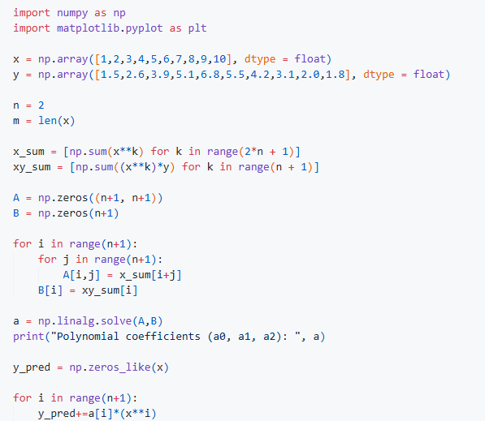

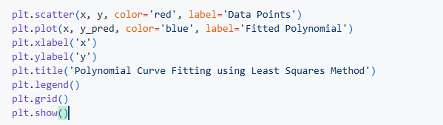

**Output:**

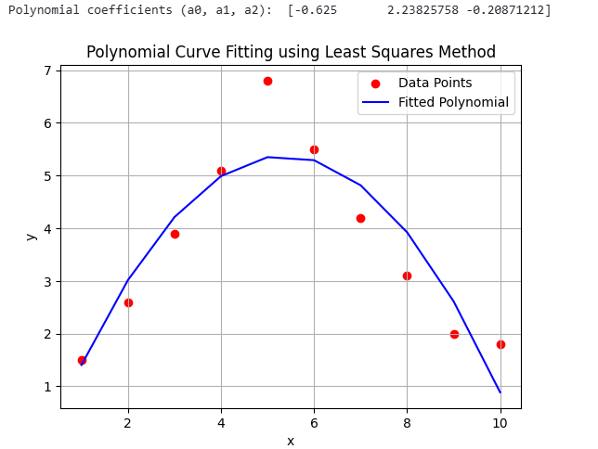

**Discussion & Conclusion**

In this experiment, a second-degree polynomial was applied to perform polynomial curve fitting on the given dataset. The resulting curve showed a strong alignment with the actual data points, demonstrating the effectiveness and precision of the method. Curve fitting plays an important role in representing complex data patterns and predicting future outcomes based on observed values. However, selecting an appropriate polynomial degree is crucial—an excessively high degree may cause overfitting, while a low degree might fail to capture the true trend. In summary, curve fitting serves as a fundamental approach in data analysis and scientific computation for understanding and modeling variable relationships.